To run mongodb on your own shell.

bn Instructions to run mondoDB in shell

1. Start the connection to database by going to C:\Program Files\MongoDB\Server\3.4\bin and run mongod.exe

2. Connect to MongoDB by oopening another terminal, going to C:\Program Files\MongoDB\Server\3.4\bin and run mongo.exe

BUT NOW as of 12/14/2018:

Open Gitbash, navigate to app folder (hair salon), then insert this command:

mongo ec2-18-207-130-153.compute-1.amazonaws.com:27017/hairsalonDB -u Casey-hairsalonDB -p Aerosmith1

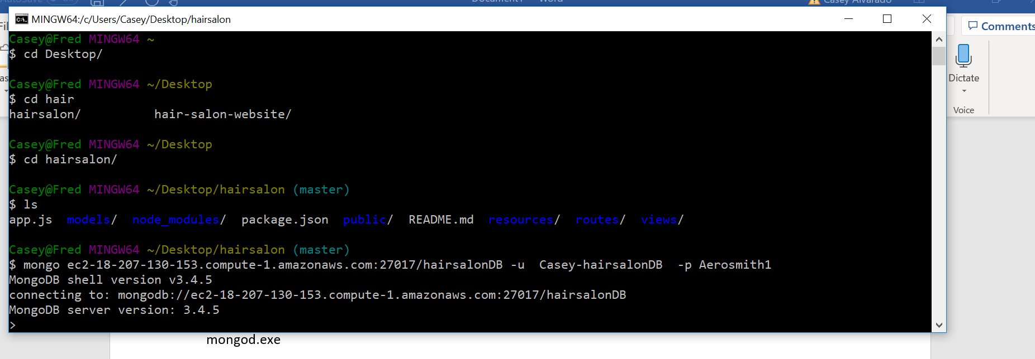

Then type

use hairsalonDB

show collections

This should show the clients collection

Then do db.clients.find().pretty() and all of the customers should pop up

As for the controlling the actual app, then use putty with the ec2-whatever instance name and the pdk and log in as bitnami

Then go to apps > hairsalon

And here you can start and stop the app.

Note: that the public dns name (the one that starts with ec2-xx) changed on me so maybe it changes every once in a while. It changed from

ec2-34-204-182-56.compute-1.amazonaws.com to

ec2-18-207-130-153.compute-1.amazonaws.com

When this happens three things:

1. Connect to mongo differently

Previously connected like

mongo ec2-34-204-182-56.compute-1.amazonaws.com:27017/hairsalonDB -u Casey-hairsalonDB -p Aerosmith1

Now connect like

\*\*mongo ec2-18-207-130-153.compute-1.amazonaws.com:27017/hairsalonDB -u Casey-hairsalonDB -p Aerosmith1

1. Need to change the uri in app.js

In Desktop/hairsalon/app.js, change the uri like so:

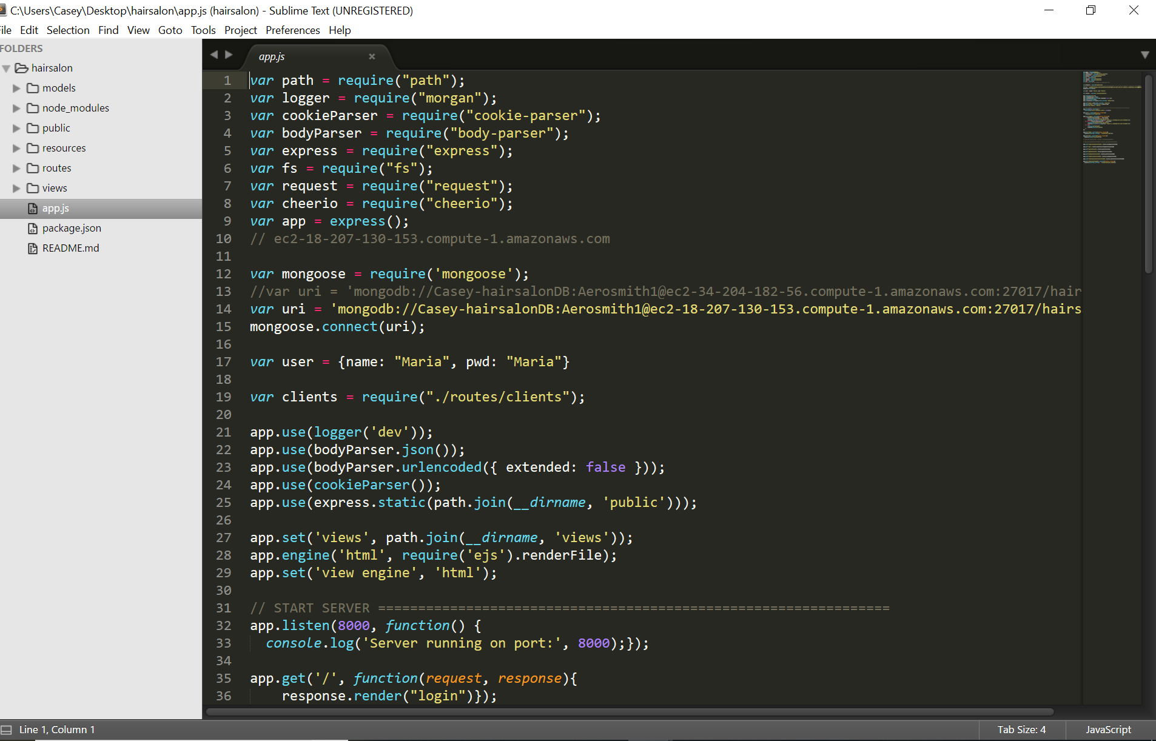

Then of course, commit and push changes on gitbash in this folder.

Then go to putty, navigate to apps/hairsalon and then do sudo git pull. Should pull from the repo I just Pushed to. Should see it say that it downloaded changes.

Then want to do forever stopall (to get new changes)

And then forever start (to make new changes go in effect)

For more clarity, see part 2 of this tutorial: <https://scotch.io/tutorials/deploying-a-mean-app-to-amazon-ec2-part-2>

1. Public dns changes

Since public dns name changed. Now to access the website online is the new public name. Previously was

WEBSITE URL: <http://ec2-34-204-182-56.compute-1.amazonaws.com:8000/home>

NEW WEBSITE URL AS OF 12/14/2018 TO ACCESS IT ON THE INTERNET IS :

<http://ec2-18-207-130-153.compute-1.amazonaws.com:8000/home>

For any confusion or whatever go through this tutorial: <https://scotch.io/tutorials/deploying-a-mean-app-to-amazon-ec2-part-1>